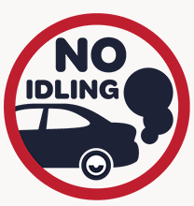
Make Chichester Idle-Free - We’re committed to making Chichester one of the cleanest, greenest areas in West Sussex and we really need your help.

Idling facts
- Too much idling can damage your vehicle.
- Idling for an hour can waste at least half a gallon of fuel
- Even modern diesel engines don’t need more than a few minutes to warm up in cold weather
- Air Quality inside a car can be worse than outside putting passengers at risk.

You can make a difference
By turning off your engine you can:
- Improve air quality inside and outside your car
- Reduce pollution
- Reduce the health risks linked with toxic air like heart disease, lung cancer and asthma
- Make our streets and level crossings nicer places to live, walk and cycle around.

Make Chichester Idle-Free - We’re committed to making Chichester one of the cleanest, greenest areas in West Sussex and we really need your help.

Idling facts
- Too much idling can damage your vehicle.
- Idling for an hour can waste at least half a gallon of fuel
- Even modern diesel engines don’t need more than a few minutes to warm up in cold weather
- Air Quality inside a car can be worse than outside putting passengers at risk.

You can make a difference
By turning off your engine you can:
- Improve air quality inside and outside your car
- Reduce pollution
- Reduce the health risks linked with toxic air like heart disease, lung cancer and asthma
- Make our streets and level crossings nicer places to live, walk and cycle around.

